**EXPERIMENT-3**

Name: K.Sriya

Roll No: 2320090043

# AIM: Configuration of basic switch setup using Huawei/Cisco network switch using cisco packet tracer.

**Apparatus Required:** PCs, Switch, Copper straight cable.

# Procedure:

**Step 1:** Open Cisco Packet Tracer.

**Step 2:** Create a simple network.

**Step 3:** Take two PCs and one switch connector.

**Step 4:** Assign IP addresses to the PCs.

* Go to PC → Desktop → IP Address
  + PC1: 192.168.1.2
  + PC2: 192.168.1.3

**Step 5:** Assign IP address to the switch.

* Go to Switch → Config
* Use some commands to give IP address.

**Step 6:** Connect PCs to switch with copper straight through cable.

**Step 7:** Go to PC → Desktop → Command Prompt, then give command to ping IP address of PC2.

# Result:

By using PC1 and switch, I have done a simple connection.

# Configure the switch:

switch > enable

switch # configure terminal switch (config) # hostname s1 s1 (config) # interface vlan 1

s1 (config-if) # ip address 192.168.1.1 255.255.255.0 s1 (config-if) # no shutdown

s1 (config-if) # exit s1 (config) # exit

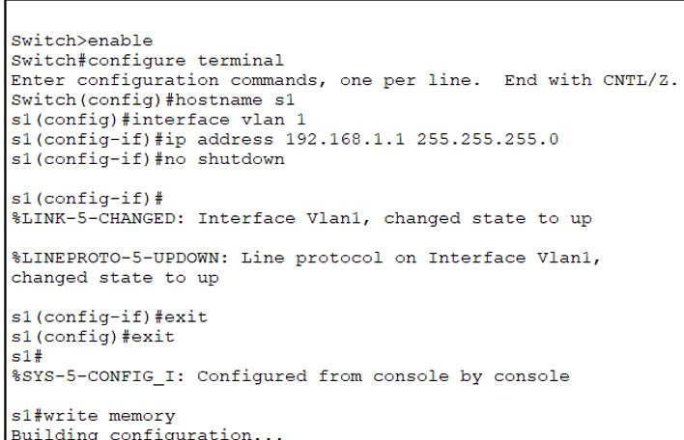**Configuring the Switch**

